

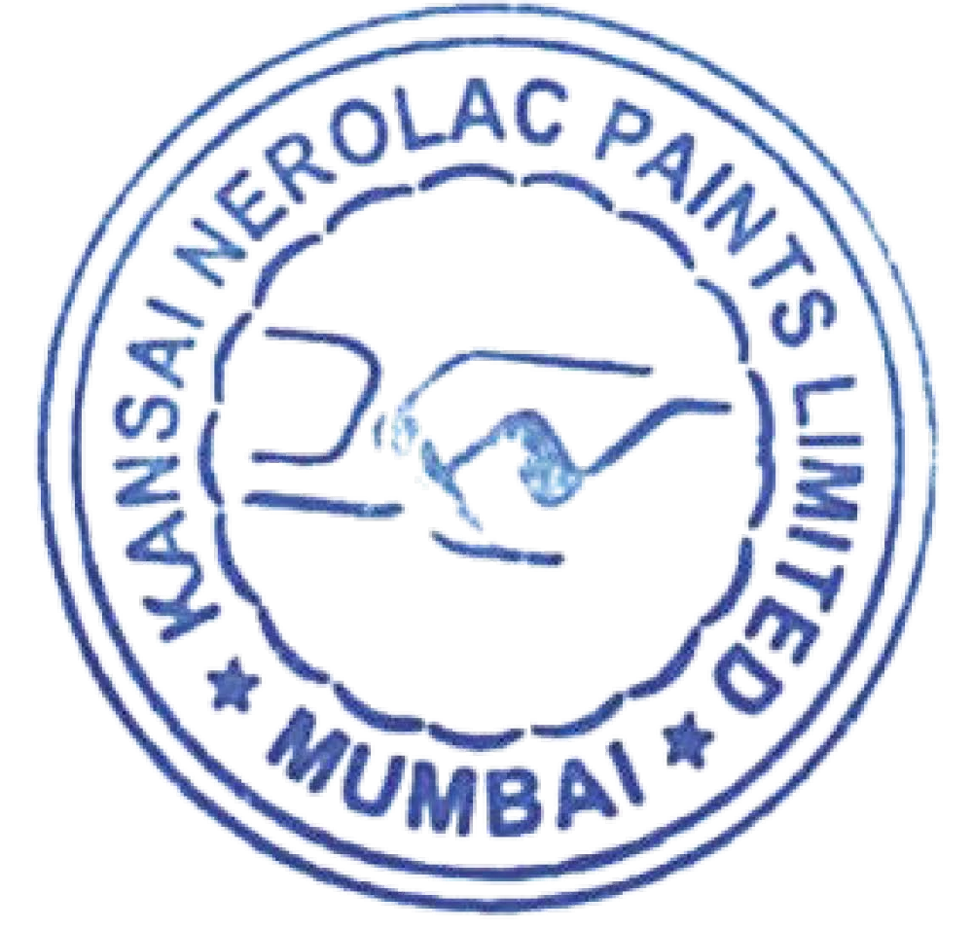

Composition of Board Committees

The composition of the Committees of the Board of Directors of Kansai Nerolac Paints Limited is as follows:

|  |  |  |
| --- | --- | --- |
| **Sr.**  **No.** | **Name of the Committee** | **Members** |
| 1. | Audit Committee | Mr. Uday Bhansali – Chairman Ms. Sonia Singh  Mr. Bhaskar Bhat |
| 2. | Nomination and Remuneration Committee | Mr. Uday Bhansali – Chairman  Mr. Bhaskar Bhat Ms. Sonia Singh Mr. H. Nishibayashi |
| 3. | Stakeholders Relationship Committee | Ms. Sonia Singh – Chairperson  Mr. Bhaskar Bhat Mr. Anuj Jain |
| 4. | Corporate Social Responsibility Committee | Ms. Sonia Singh – Chairperson  Mr. Bhaskar Bhat Mr. Anuj Jain |
| 5. | Risk Management Committee | Ms. Sonia Singh – Chairperson  Mr. Anuj Jain  Mr. Uday Bhansali Mr. Hirokazu Kotera Mr. Jason Gonsalves  Mr. Prashant Pai – Chief Risk Officer |

The constitution of these Committees satisfies the requirements of the Companies Act, 2013 and Securities and Exchange Board of India (Listing Obligations and Disclosure Requirements) Regulations, 2015.